**WATER TANK CONTROLLER WITH QUALITY CHECK**

Nandith R (26.02.2022)

# **INTRODUCTION**

Water tank controller with Quality check is a system that shall be used to refill water tanks in houses and commercial buildings and monitor the water quality as well. This helps in elimination of manual monitoring and refilling of water tanks. The major advantages of the system is that it helps in automating tasks and also there is no wastage of water overflowing from tanks. It also provides the facility to check water quality as well. The components used in the system is very simple which makes the product economically accessible as well. The overall system development phase is explained.

## **OBJECTIVE**

* To monitor the quality of water and alert the user.
* To refill the water tank automatically without any wastage of water and power.

## **REQUIREMENTS**

## **HIGH LEVEL REQUIREMENTS:**

|  |  |
| --- | --- |
| **ID** | **DESCRIPTION** |
| HLR 01 | To Refill the water tank automatically when tank becomes empty. |
| HLR 02 | Alert the user when the tank is filled. |
| HLR 03 | To check the quality of water and alert user. |
| HLR 04 | To turn ON the motor when the tank is empty. |
|  |  |

## **LOW LEVEL REQUIREMENTS:**

|  |  |
| --- | --- |
| **ID** | **DESCRIPTION** |
| LLR 1 | A Microcontroller is used for controlling the process. |
| LLR 1.1 | A water level sensor is used to check the water level. |
| LLR 2 | Buzzer is used to alert the user. |
| LLR 3 | A water Quality sensor is used to check the quality of the water |
| LLR 4 | A Motor Driver shall be used to switch ON the motor. |

## **SWOT ANALYSIS**

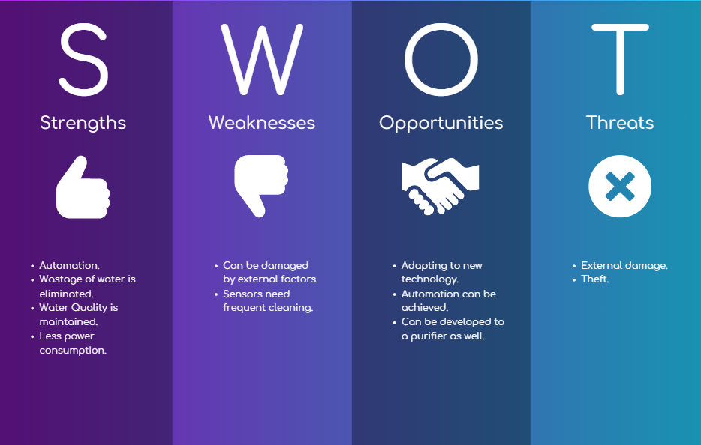

## **5W’S 1H**

**What -** This a controller that helps to automatically refill the water tank using sensors and micro controller.

**When** - It is used when we need to fill water to the pressure tank.

**Where** - It can be used in domestic, Industrial as well as Commercial complexes.

**Who** - Normal consumers are the people who use this.

**Why** – In order to refill water to the tank without wastage.

**How** - By using a micro-controller, sensors and few actuators.

## **BLOCK DIAGRAM & COMPONENTS:**

## **BLOCK DIAGRAM**

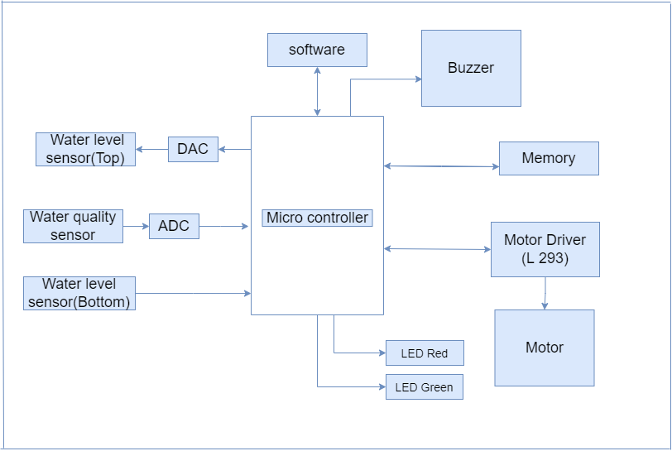

**Microcontroller**

Microcontroller is used to control the overall process in automating the refill of water into the tank.

## **SENSORS**

**Water level sensor**

Two water level sensors are used to detect the water level. One for detecting if the tank is empty and another one detecting the top level of the tank.

**Water Quality sensor**

A water quality sensor is used to check the sediments and excess chlorine in the water and alert the user.

## **ACTUATORS**

**Motor Driver Circuit**

Motor Driver circuit is used to switch on and off the based upon the signals received from the sensors.

**Buzzer**

A buzzer is used to alert the user once the tank is filled.

**LED’s**

Two LED’s are used to alert the user regarding the quality of the water.

* RED – The water is impure.
* GREEN – The water is pure.

**Power Supply**

AC power supply is converted to DC and given to the circuit in order to run it.

# **ARCHITECTURE**

# **BEHAVIOURAL DIAGRAM**

**HIGH LEVEL BEHAVIOURAL DIAGRAM**

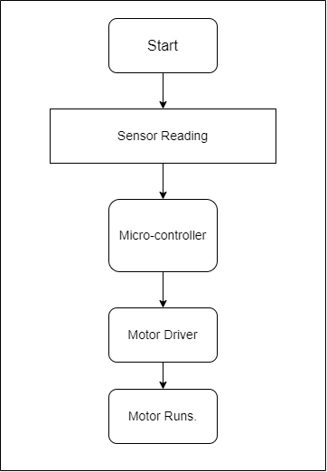

**LOW LEVEL BEHAVIOURAL DIAGRAM**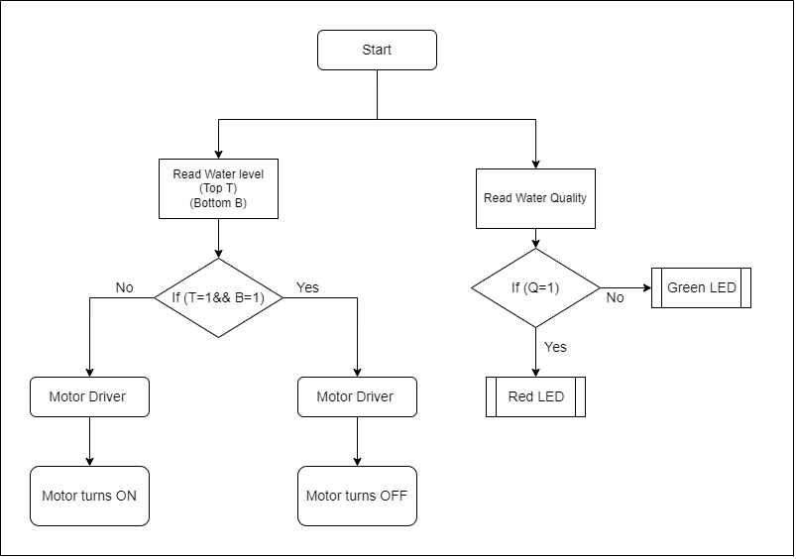

### **STRUCTURAL DIAGRAM**

**HIGH LEVEL STRUCTURAL DIAGRAM**

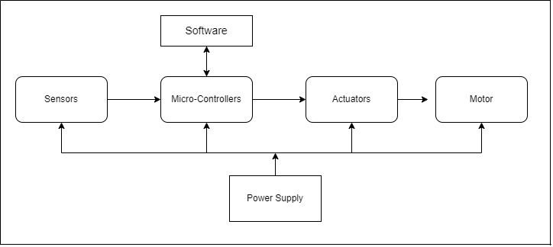

**LOW LEVEL STRUCTURAL DIAGRAM**

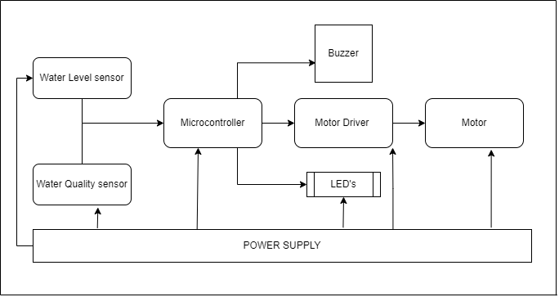

## **APPLICATIONS**

• Houses

• Industries

• Schools

• Hospitals

• Commercial complexes